Trip Planner for Beginner App

By

Muhammad Izzat Bin Kamarul Ariffin

AM1909006091

A project proposal

Submitted to

Ms SHUHADAH OTHMAN

Faculty of Computing & Multimedia Kolej University

Poly-Tech MARA

0721

Contents

**1.0 Introduction** 3

**2.0 Problem Statement** 4

**3.0 Project Objective** 5

**4.0 Scope** 6

**5.0 Target User** 7

**6.0 Project Requirement** 8

**7.0 Project Methodology** 9

**8.0 Conclusion** 10

**9.0 Gantt Chart** 11

**10.0 Reference** 12

# **1.0 Introduction**

Trip Planner for Beginner is an application that makes it easier for tourists to travel abroad or within the country more easily. This application is made especially for experienced or new travelers, this application will organize your schedule so that you are not fussy when traveling to places that have never been visited

# **2.0 Problem Statement**

# **3.0 Project Objective**

# **4.0 Scope**

# **5.0 Target User**

# **6.0 Project Requirement**

# **7.0 Project Methodology**

The methodology I want to use in this project is Rapid Application Development. The reason I want to use this methodology is that Rapid Application Development (RAD) is an effective methodology that provides faster and higher quality results than using the results of other methodologies. This methodology is designed to facilitate maximum profit from software development. The main objective of this methodology is to accelerate the development of the software development process.

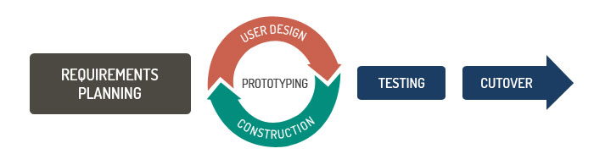

**Figure 1: Rapid Application Development (RAD)**

# **8.0 Conclusion**

# **9.0 Gantt Chart**

|  |  |  |  |  |  |  |  |  |  |  |  |  |  |  |
| --- | --- | --- | --- | --- | --- | --- | --- | --- | --- | --- | --- | --- | --- | --- |
| **Project Schedule** | **W1** | **W 2** | **W 3** | **W 4** | **W 5** | | **W 6** | **W 7** | **W 8** | **W 9** | **W1 0** | **W1 1** | **W1 2** | **W1 3** |
| Information Gathering |  |  |  |  |  | |  |  |  |  |  |  |  |  |
| Literature Review |  |  |  |  |  | |  |  |  |  |  |  |  |  |
| Methodolo gy |  |  |  |  |  | |  |  |  |  |  |  |  |  |
| System Requirement |  |  |  |  |  | |  |  |  |  |  |  |  |  |
| Analysis |  |  |  |  |  | |  |  |  |  |  |  |  |  |
| Design |  |  |  |  |  | |  |  |  |  |  |  |  |  |
| Implementation |  |  |  |  |  | |  |  |  |  |  |  |  |  |
| Testing |  |  |  |  |  |  | |  |  |  |  |  |  |  |

**Table 1: Show the Gantt Chart for the Project Schedule**

# **10.0 Reference**